
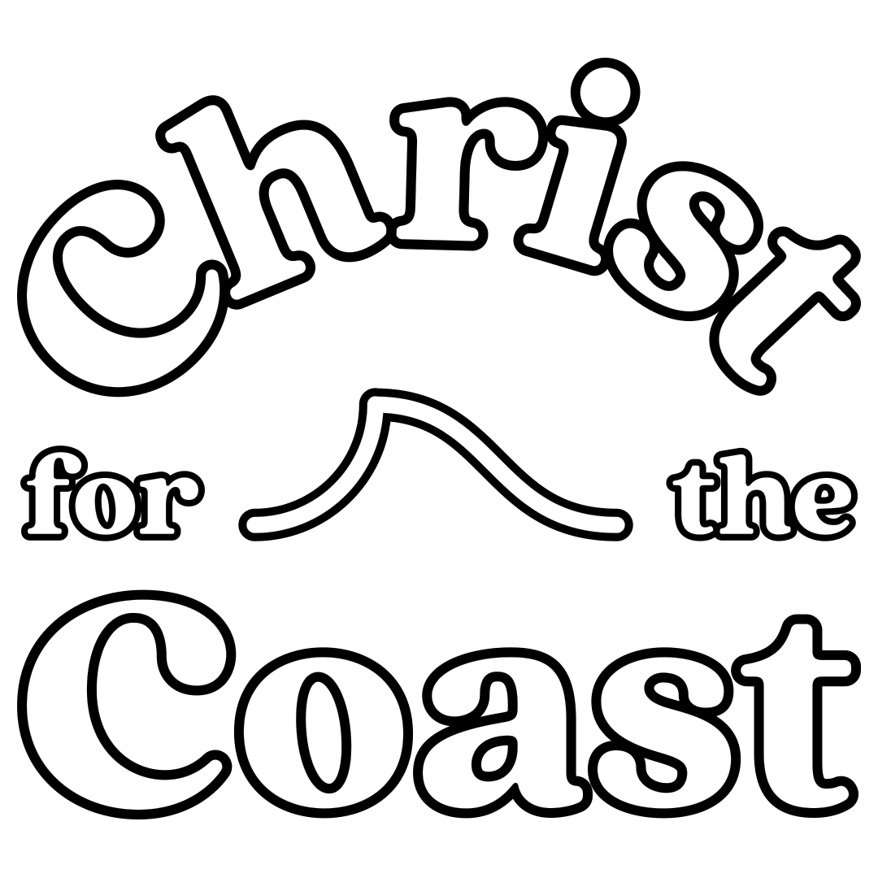

Permission Note – Christ for the Coast
I give permission for _________________________________________ to attend Christ for the Coast under the care of [enter your church group’s name here] at Figtree Anglican Church on March 6th 2026.
I give permission for my child to be driven to the event: (please tick)
- With a fully licenced driver
- With a provisionally licenced driver (I.e. P-plates) where necessary
- With this specific person: ____________________
- I will drive them myself

Other relevant information (e.g. medical conditions or other factors which may impact their experience of the event): ____________________________________________________________________________________
__________________________________________________________________________________________________________________________________________________________________________________________________
Parent / guardian name: ______________________________________________
Parent / guardian contact number: ______________________________________________
Parent / guardian signature: ______________________________________________
Date: ______________________________________

